ChatGPT Prompt Engineering for Developers course notes and links-

# Introduction-

<https://learn.deeplearning.ai/courses/chatgpt-prompt-eng/lesson/1/introduction>

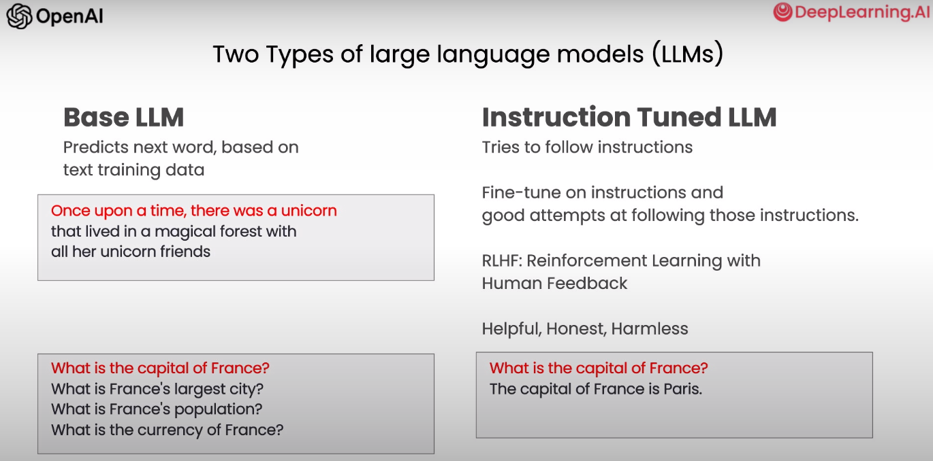

# Guidelines-

<https://learn.deeplearning.ai/courses/chatgpt-prompt-eng/lesson/2/guidelines>

